ADD template (Architectural Design Document).
Italicised text conveys an instruction or an explanatory comment.
The ADD requires a formal cover page, an authorisation section, a revision history, and a list of contents.
1 | Introduction
1.1 | Purpose of the document
1.2 | Scope of the software
1.3 | Conventions  Introduce any special notations e.g. the construction of component identifiers.
1.4 | Overview of the document  The overview may be presented as a formal abstract or executive summary.
2 | System Overview  Summarise the system context and the system design.
3 | System Context  Describe the system context (with diagrams if appropriate).  Define the external interfaces.
4 | System Design
4.1 | Design method  Describe or reference the design method and tools, and the programming languages.
4.2 | Decomposition description  Describe the system design (with diagrams).  Show the components, and the control and data flows between them.
5 | Component Description  Describe each component.  Structure this section according to the design.
5.n | [Insert component identifier]
 | 5.n.1 Type Say whether the component is a module, a file, a program etc.
 | 5.n.2 Purpose Trace the component to the software requirements.
 | 5.n.3 Function Say what the component does.
 | 5.n.4 Subordinates List the immediate children.
 | 5.n.5 Dependencies Describe the pre-conditions for using the component.
 | 5.n.6 Interfaces Describe the control and data flows to and from the component.
 | 5.n.7 Resources List the computing resources required e.g. displays, printers.
 | 5.n.8 References Reference any documents needed to understand the component.
 | 5.n.9 Processing Describe the control and data flow within the component.
 | 5.n.10 Data Define in detail the data structures and file structures used to interface the major components. Otherwise give an outline description.
6 | Feasibility and Resource Estimates  Summarise the computer resources needed to build, operate and maintain the software.
7 | Requirements Traceability Matrix  For each software requirement tabulate the corresponding component(s).
8 | References
9 | Glossary  List and explain specialised terms and abbreviations.

Introduction

1.1 Document Purpose
The purpose of this document is to provide an outline design specification for a Silvering Line Paint Curtain Inspection System.

1.2 Software Scope
The scope of the software is to control the running of the inspection system, provide tools for setup and maintenance, and interface to plant via Digital Outputs and an OPC server that will provide basic statistics on faults. The system has no knowledge of plates and cannot distinguish whether a fault in the paint curtain will result in a fault on the product. It cannot therefore track plates with faults on. This type of functionality if required will have to be provided in the PLC/SCADA system.

System Overview

2.1 The Inspection Task
The Paint Curtain Inspection System (PCIS) will provide a means for 100% monitoring of the integrity of the Paint curtain via a Vision system. The system will register report faults in the following categories:
- Blips (a discrete hole in the paint curtain)
- Streams (a continuous gap in the paint curtain)

Note: Curtain Thinning is a pre-stream fault and a such cannot easily be distinguished from a stream and will be reported as a stream.

The size of faults etc can be seen in the requirements spec.

2.2 System Architecture
There are 2 areas in close proximity where this system is required i.e. at the red and green paint curtains and whilst the systems will share a single electrical cabinet they will be completely separate and identical. All of the design detail listed here will be duplicated across both systems including separate plant interfaces. By doing this both can run independently and this removes any inter-reliance.

3.0 System Context

3.1 Plant Environment
The camera and lighting equipment will be situated in a hazardous environment with risk of explosion due to a high concentration of solvent in the atmosphere. All electrical equipment must be housed in zone 1 rated intrinsically safe explosion proof housings.

3.1 Opto - Mechanical Arrangement
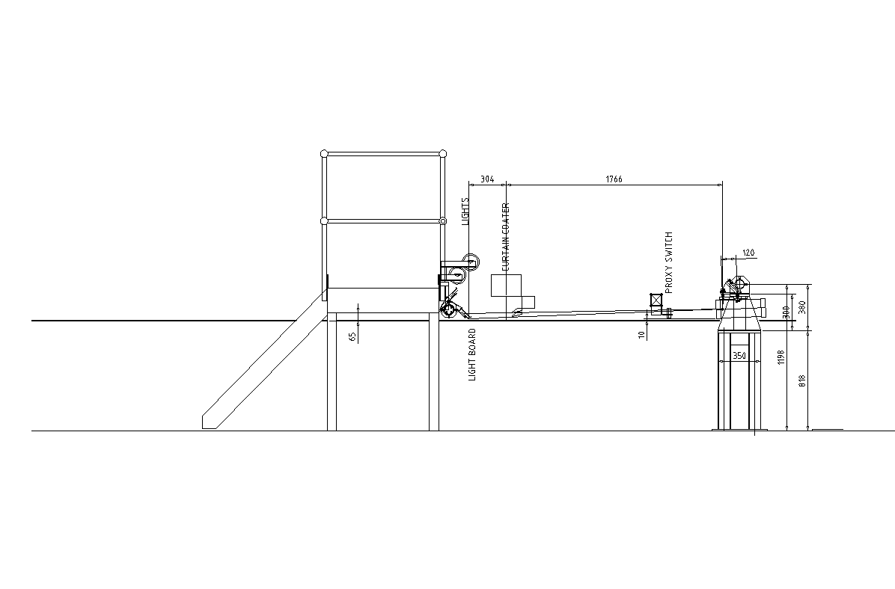
- Three 1.5m fluorescent lamps will be place across the line with the centre lamp overlapping the outer lamps the fill in the gap.
- The lamps will illuminate a white strip of material (board) with a uniformly scattering surface which is what the camera will see (albeit out of focus) through holes in the paint curtain.
- The lamps must be kept close (300mm) to the board so as to increase the amount of light scattered to the camera.
- The distance from the camera to the board was found by experimentation to be less critical, but is set by the choice of lens (field angle) and the required coverage in the object plane. Due to the limitations in altering the existing plant installation (photocell beam) a 28mm focal length lens will be used with a F2.0 aperture. This will be sited about 1780mm from the curtain with a further 300mm to the board.

3.2 Electrical Equipment
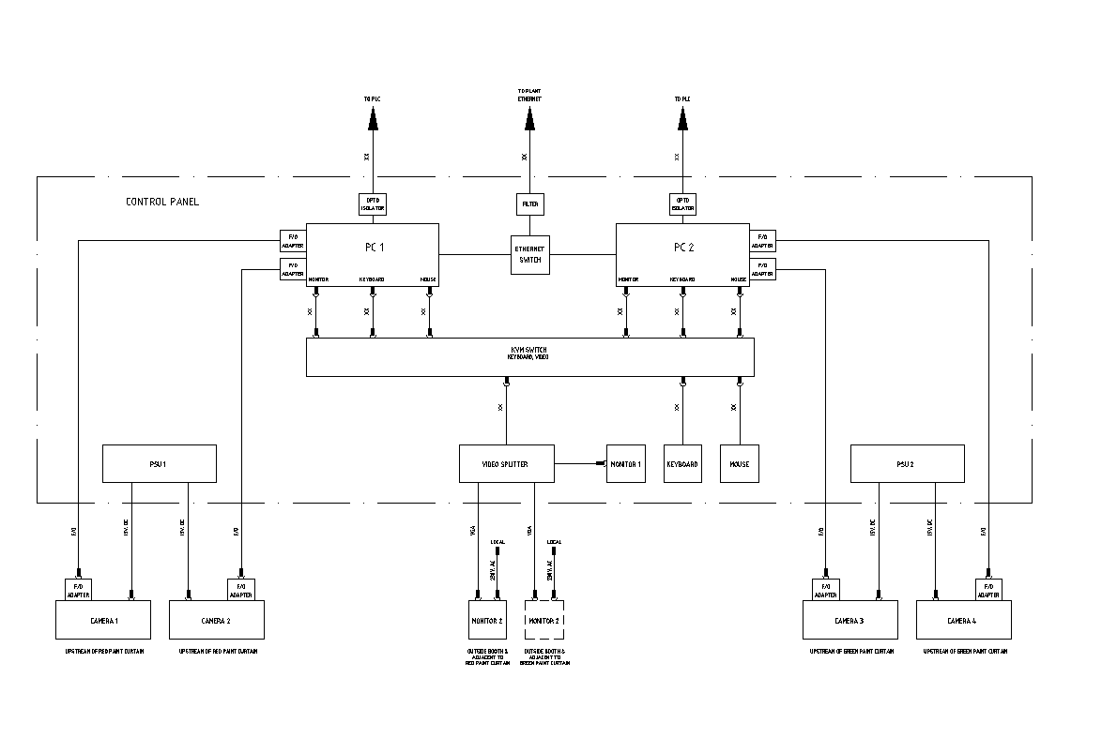
- The cable run exceeds the 10m maximum in the cameralink specification so a fibre optic line driver must be used between the cameras and the PC in the cabinet.

- A single 15Vdc supply will be fed to each camera housing where it will be split to feed the camera(12-15V) and the FO driver (5-24V). 15V has been chosen as the cable length will be ~30m and this will allow for some volt drop in the cable.

- A video splitter is used so that an extra monitor can be placed where the engineer can see it when adjusting the camera alignment on both systems.

- A KVM switch is used in the panel to enable both system PCs to be accessed from a single keyboard mouse and monitor.

3.3 Plant Interface
Real Time
The system will report the above faults in real time to the PLC via a single Digital Output.
- Each Blip will result in a short (~2s) pulse on the output.
- Streams will result in the output being switched on for their duration.

Statistical
The system will provide an OPC server that will provide statistics gathered whilst the system is operational. It will be responsibility of the OPC client program to ensure persistence and store any historical trend information required.
The following statistics will be provided for each fault category:
Total for the current hour (reset on the hour)
Total for the last 8 hours
Total for the current day (since midnight)
The connection will be established through the plant Ethernet.
Electrical Signals
Electrical Isolation will be provided for the output signals sent to the PLC using Optocouplers. This protects the system from wiring errors etc.

4.0 Software System Design

4.1 Inspection Technique
The inspection system will have 2 Linescan cameras that cover the curtain to the extent of the largest plate (3210mm) plus some extra at the edges (3400mm total) and with some overlap in the middle (~50mm).
The system will not attempt to compensate for the statistically small amount of double counting that may result from the overlap (if necessary the overlap can be removed in software).
The lighting will be placed behind the curtain such that when the curtain is present and functioning correctly then all light will be obscured from the camera (below the threshold) giving a dark field system. Faults will appear as white objects on a black background.

Caveat: with a dark field system it is difficult to distinguish between no faults and system failure e.g. misalignment, lamp failure etc. Also dirt on the reflector board could result in local detection dead spots.

It is intended that the light levels achieved will saturate the camera thereby removing the need for background correction which will simplify setup.

4.2 Processing
The raw image will have the following processing steps applied to it:
- threshold (to determine if there is anything to process)
- blob detection (to size the faults)
- vertical stitching (of faults that are touching the bottom) for continuous faults
- Fault Reporting

4.3 Fault Reporting
The Faults will be reported via the user interface on a Fault Map representing time on the vertical axis and position on the horizontal axis.
The horizontal axis of fault map will be divided into a series of 16 zones for position and these zones will be marked up on the bridge so that the operator can easily identify where the fault has occurred.
Faults will be aggregated together in terms of time and position zones.

4.4 User Interface

4.5 Use Case
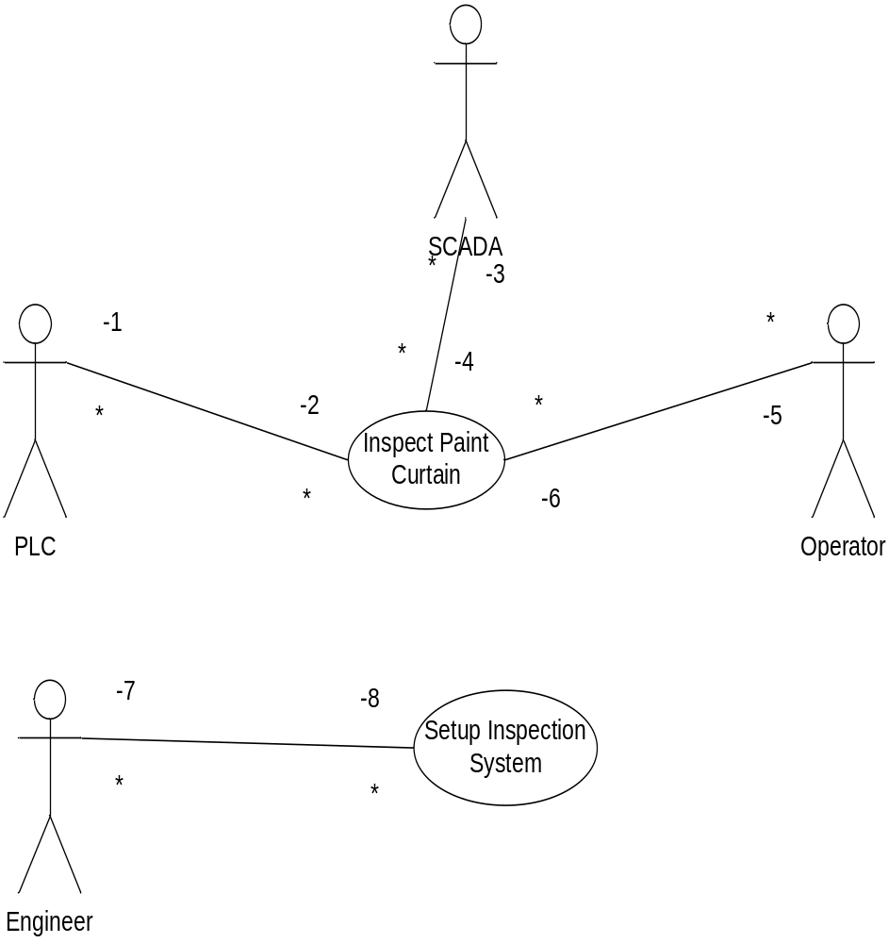

Use Case Description
There are two main use cases for this system:
1) Inspect Paint Curtain
This use case implements a dark field inspection system taking data from two cameras covering 3.4m in total of the paint curtain with an overlap in the centre. The system reports blips and streams as faults and communicates them to the PLC in real time via output lines and provides an OPC server link to the SCADA system for statistical reporting.

The PLC is the Primary Real time user of the system, has a hardware link to the paint curtain inspection system. Two outputs from the system provide real time information to the plc.

The SCADA system is a Primary non- real time user of this system connecting via OPC and polling the system periodically gathering statistics.

The Operator is a Primary user of the system responding to alarm conditions reported by the PLC.

2) Setup Inspection System
This use case provides graphical tools to allow optical alignment of the inspection system.
The Engineer is the Primary user of this system using the graphical tools to setup and periodically check the optical alignment of the system.

4.6 Class Diagram

